This is a tutorial o how to make your own workspace in oracle 11g.

If you are looking for installing sql developer and connecting your oracle 11 g with your sql developer, go to part 2. 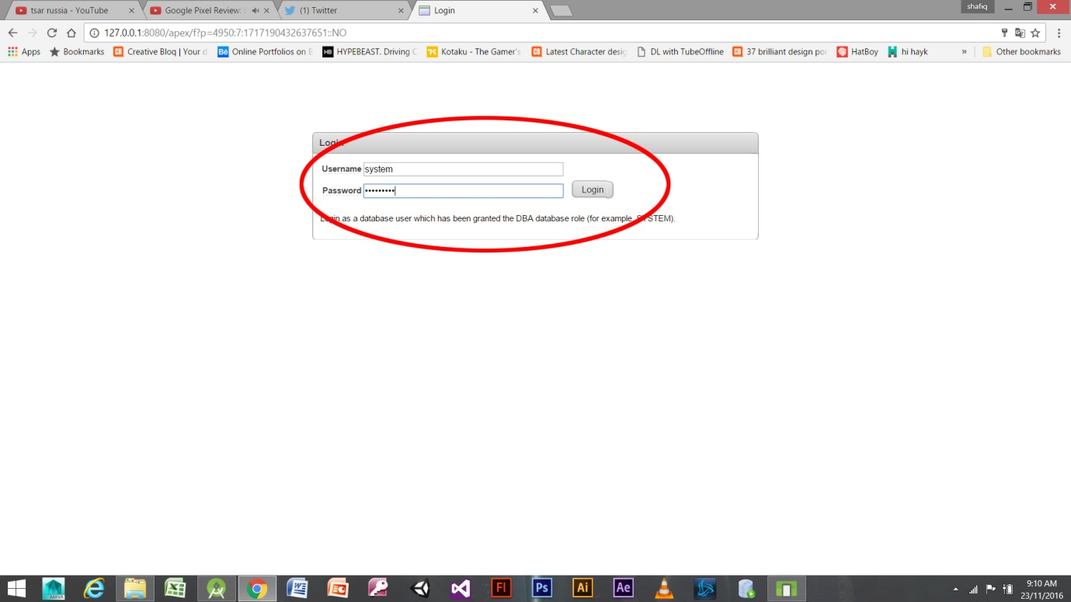

Step 1

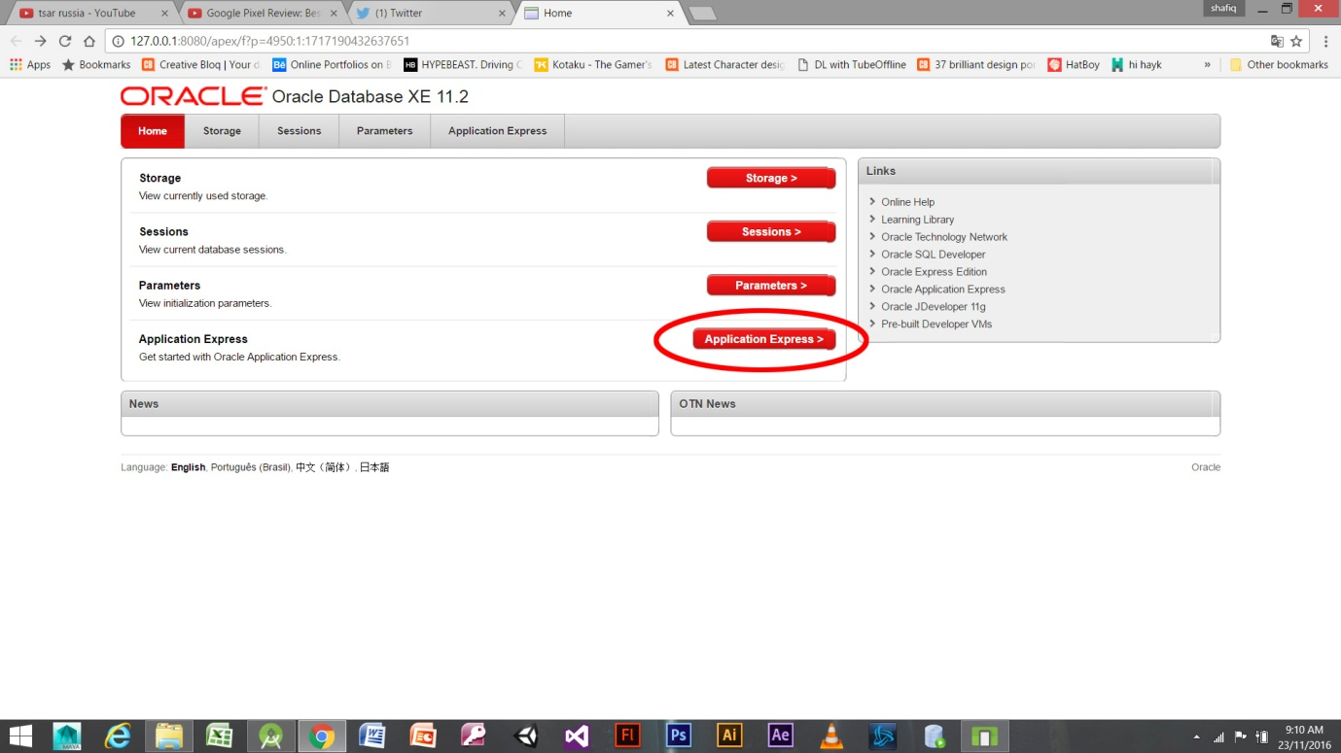

Step2

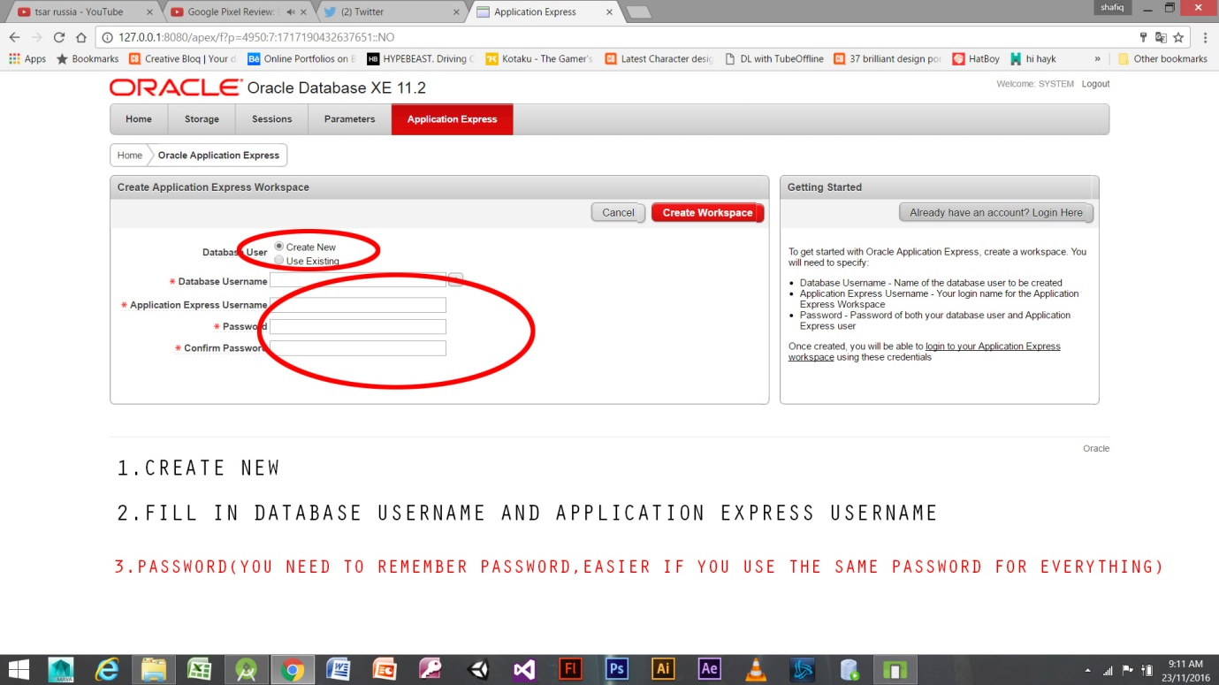

Step 3

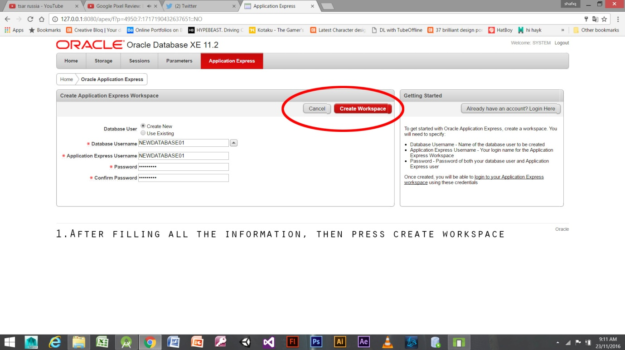

STEP4

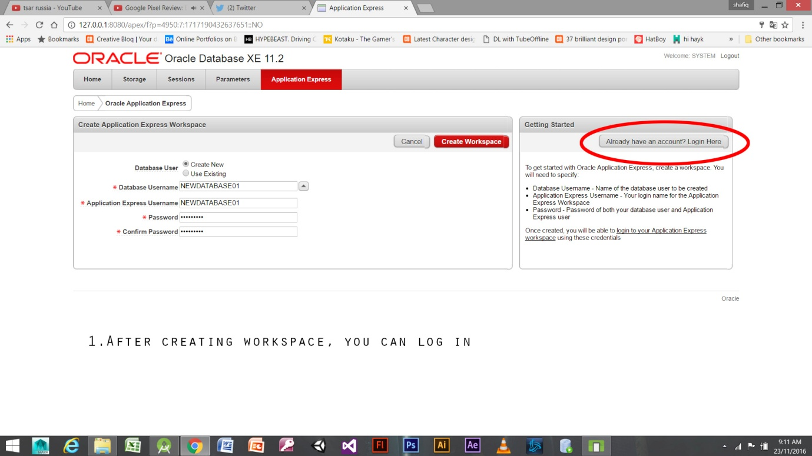

STEP 5

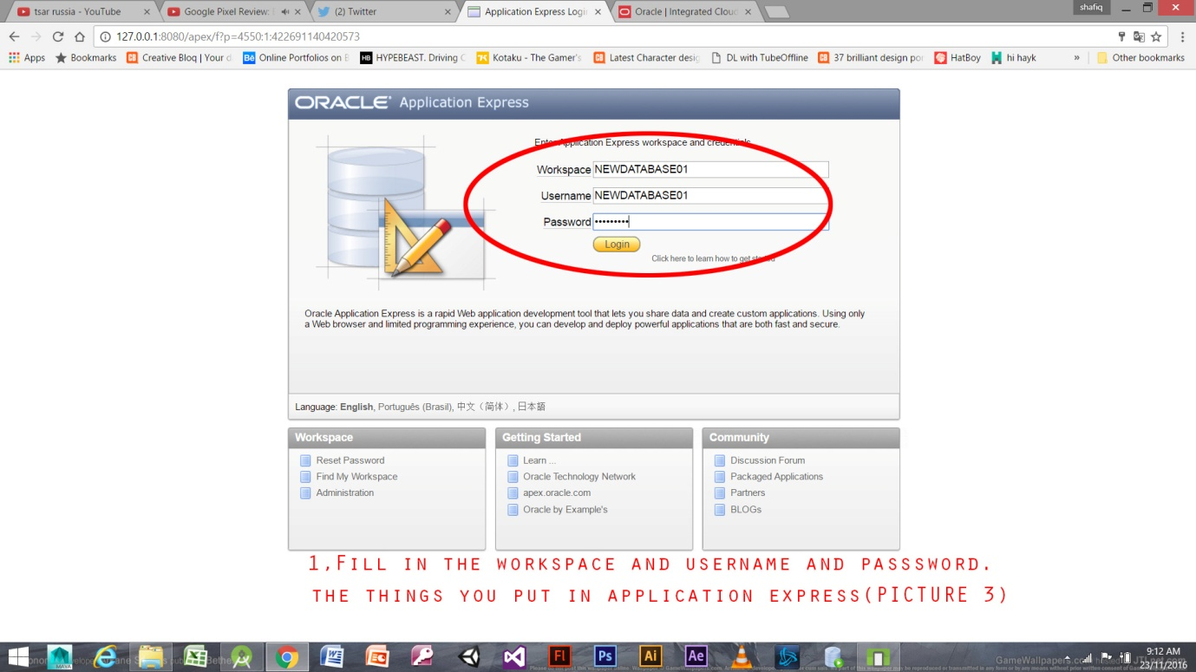

STEP 6

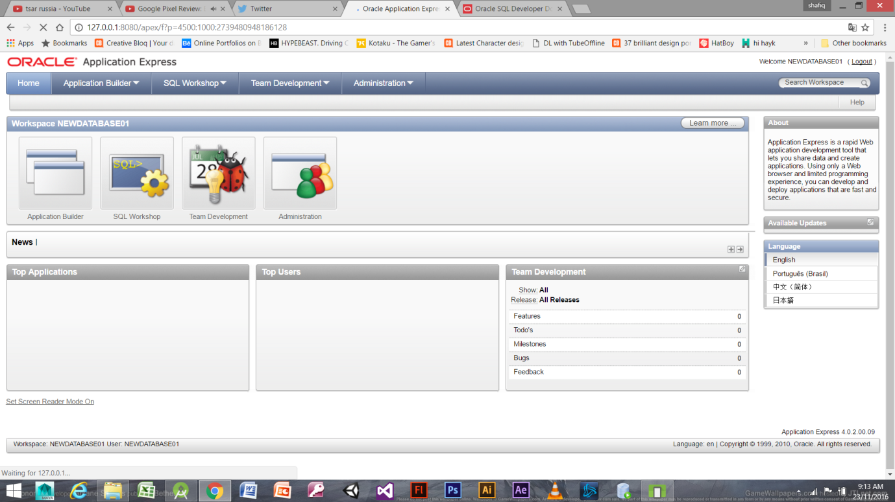

FINISH.   
  
PART 2-INSTALLING SQL DEVELOPER.